## Data Stories: Writing guide and process

Data stories present key data points from practice/research work or surveys to explain an issue or support an argument, for a general audience. The data is set against a narrative and the broader context of the topic being presented.

It is not necessary to present every single finding of a survey or report in a data story; the focus can be on key highlights of interest, one particular part of the study, or even just one interesting finding.

**What can data stories do?**

* Generate wider interest around research/practice in specific sectors
* Inform and build awareness on research/practice work that has implications on the public
* Reach policy makers and other practitioners who read public media platforms

**What data stories are not**

* A presentation of all the findings of a survey
* A summary of a piece of research or practice report
* A number-heavy piece not tied to a broader narrative

**Audience**

* General public, busy, with no prior knowledge
* Policymakers, practitioners from similar or different sectors (with varying levels of prior knowledge)

When planning a data story, looking for potential platforms to pitch the story can help to understand the audience, and tailor the story accordingly. Looking for platforms also helps to read previously published pieces and understand the writing style, level of detail, kind of topics covered etc.

Before you begin writing, ask yourself the following questions:

* **What stands out in the report/research ?**

*This is usually highlighted early on. Unlike a report which would begin with the aims of the study, methods and then the findings, for a data story you can highlight the most important findings (hopefully one with a human interest perspective) in the early paragraphs to draw in the interest of the reader.*

* **Why is that data point/highlight important for the public?**

*Bringing in a public interest perspective is essential. Links with factors like health, environment, pollution, water quality, jobs, housing are a good way to do this, and these connections should be made right at the beginning. For example, for a data story on training of masons in building septic tanks, you could begin with emphasising the consequences (health hazards, ground water pollution) of incorrectly built tanks.*

* **How can you quickly explain the background and context?**

*All technical terms and insider jargon will have to be explained briefly, with just enough information to help the reader understand the concept, avoiding unnecessary, long drawn details. A very quick summary of the organisation, the project/study, and the main problem will also be presented.*

* **Can you keep it timely by finding a news peg?**

*A news peg always helps in keeping your piece relevant by linking it with current events and making it easier to get accepted. It could link to recent happenings like a global development in the same sector, a specific event (like a natural disaster, water crisis, a strike in a particular city), a special occasion (World Water Day) or the anniversary of an event (three years since the launch of the Smart Cities Mission in Pune)*

* **How can you build a narrative? Where can you get this additional info from?**

*Editors of media platform love anecdotes and examples. Using plenty of examples from the field can really help build the narrative. These can work especially well as the lead sentence, and can also be interspersed through the story with the findings and numbers.*

*If the research is ongoing, do collect interviews and quotes especially for data stories. If fieldwork is already completed,think of other ways to get this information (Going back to the field/ getting in touch with partners/ looking through existing field notes for interesting asides)*

* **If this has already been written about, what new perspectives can you bring out?**

*Look for other public writing on this topic to see what new data and perspectives you can bring in. Topics written about very often (like lack of toilets, inadequate public transport, issues of housing resettlement) would need some new perspectives or new ways of presenting the data.*

* **Are there any solutions or recommendations proposed?**

*Readers and editors of mainstream publications are usually interested in recommendations, solutions, suggestions on the way forward rather than highlighting the problem alone. Look for these to end the data story.*

Other things to note:

* Please get in touch with the Word Lab before you start writing for help with structuring and finalising your topic. This will help avoid too many changes at the editorial stage.
* The length of data stories can vary based on the topic and the publication, and can roughly be between 800 and 1400 words.
* Before writing, form a structure, note down important points and arguments. Write a short pitch on what the piece is about, which you will need while sending it to potential publishers. Writing a short strapline also helps firm up the idea and structure the flow.
* Check if the publication you wish to target has its own writing guide or requirements from stories, and make sure you will be able to follow these.
* Get any additional information, sources. For secondary sources, ensure these are authentic sources, well known websites or publications and that no links are broken.
* Do not use academic citations. Hyperlink sources into your piece once you write if they are online. If they are not online, they can be quoted as a sentence.
* How do you visualise the data? If the data is not already in charts and graphs, think about ways of presenting this.
* After writing, read through the piece to check if it is coherent, conveys your main points, and if it connects with your original pitch and strapline. Check for flow, spelling and grammar.

**Examples:**

A data story on why training of masons is essential as part of India’s sanitation drive, based on a report that presented findings from a survey in two town panchayats in Tamil Nadu.

Excerpt from published report:

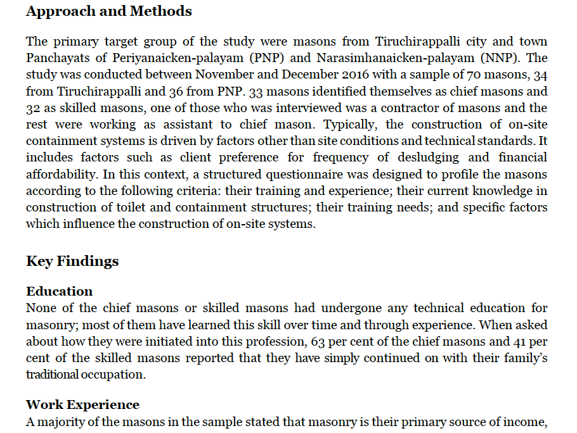

For the published data story, the lead paragraphs narrated an example from fieldwork, which reflects the main data highlight (Masons are not formally trained). It is also highlighted early on how this topic is connected to sanitation (which is obvious only to a practitioner but may not be for a lay reader), and the public interest links of public health and environmental risks are emphasised.

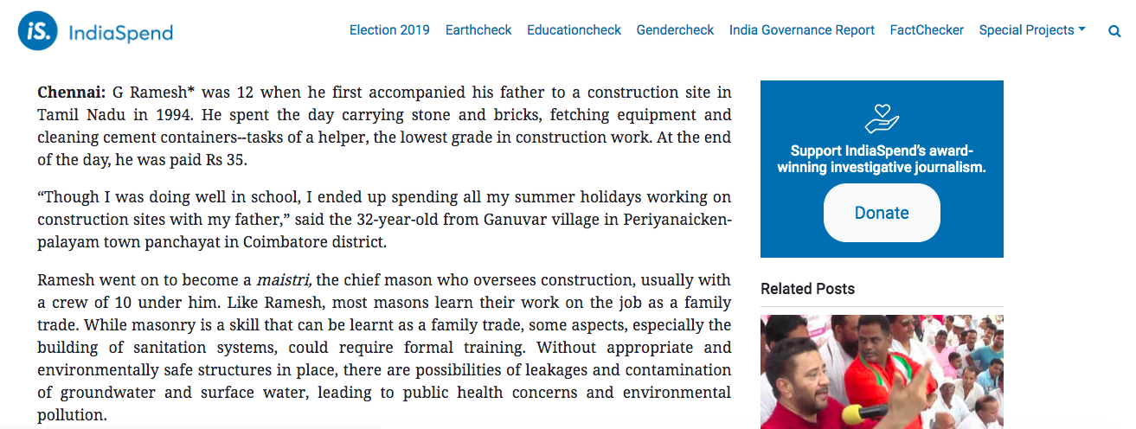

Next, the technical context and background were introduced and explained in fair detail.

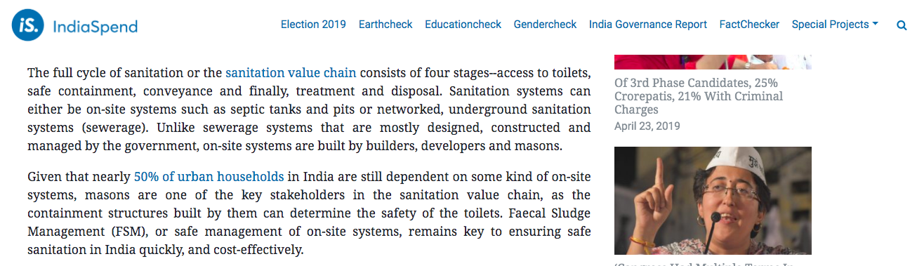

* Then, the key findings and data from the report were introduced and interspersed with field inputs and explanations.

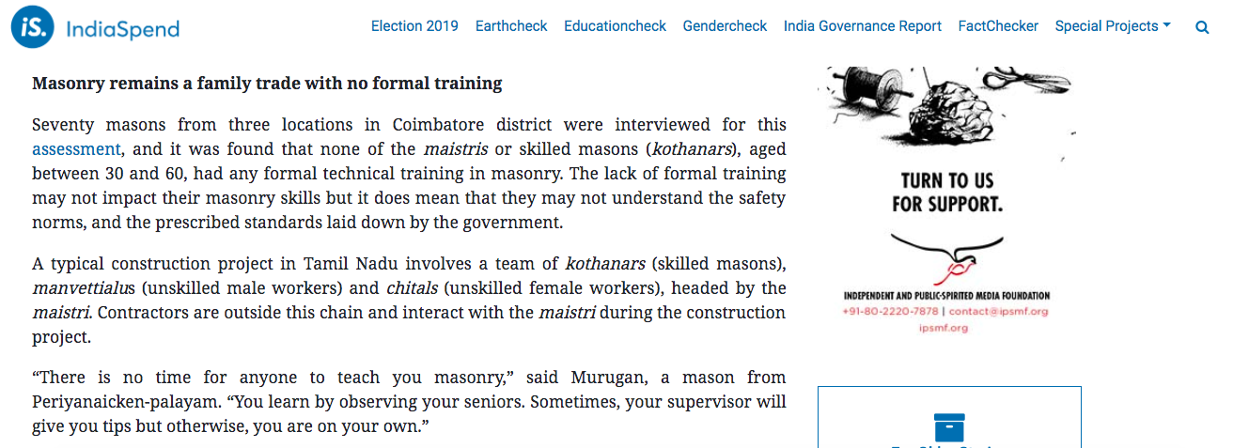

* The data story concluded with the main takeaways from the study, future steps to take, ways forward.